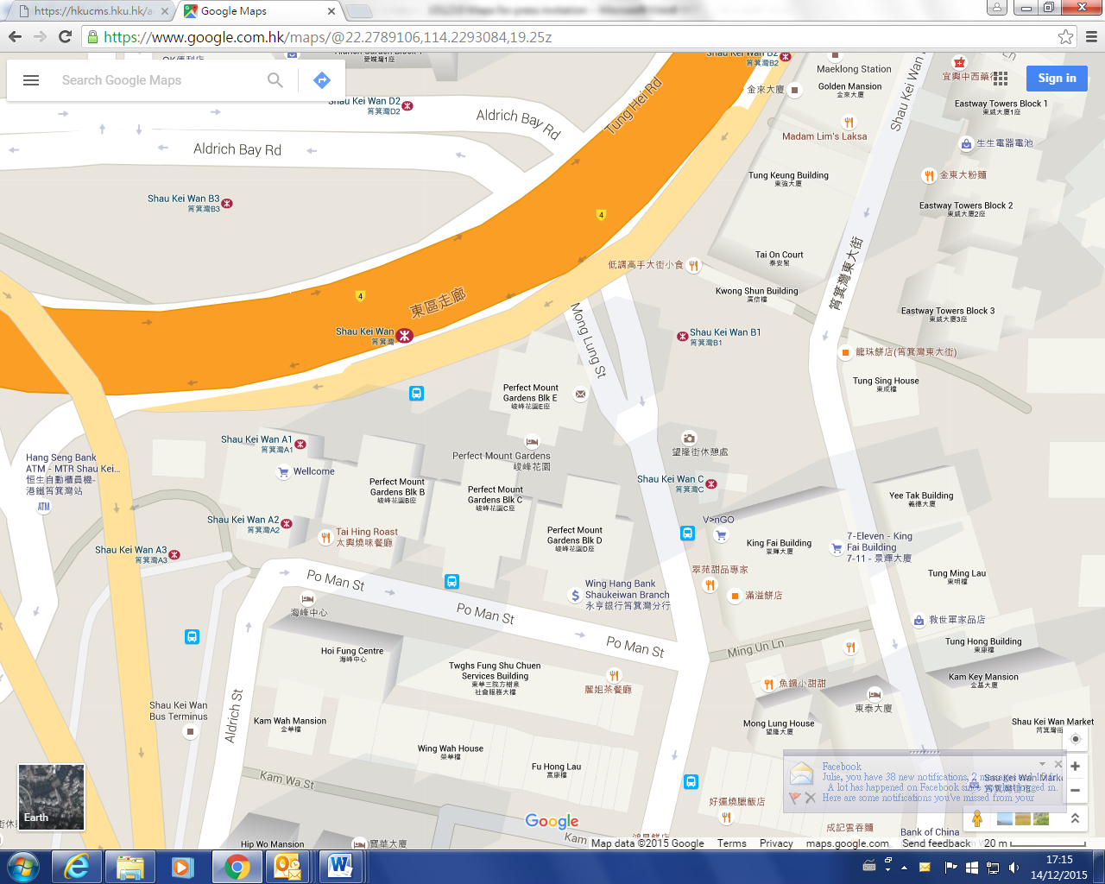

**Media pick-up point 1**

**(For those using public transportation):**

**HKU shuttle bus to pick up reporters on the curb-side of Mong Lung Street**

**near MTR Shau Kei Wan Station Exit B1**

**\*\*The shuttle will depart at 1:35pm**

**傳媒集合點2**

**(自行駕車前往之傳媒):**

**鯉魚門度假村正門**

**\*\*集合時間為下午1:50**

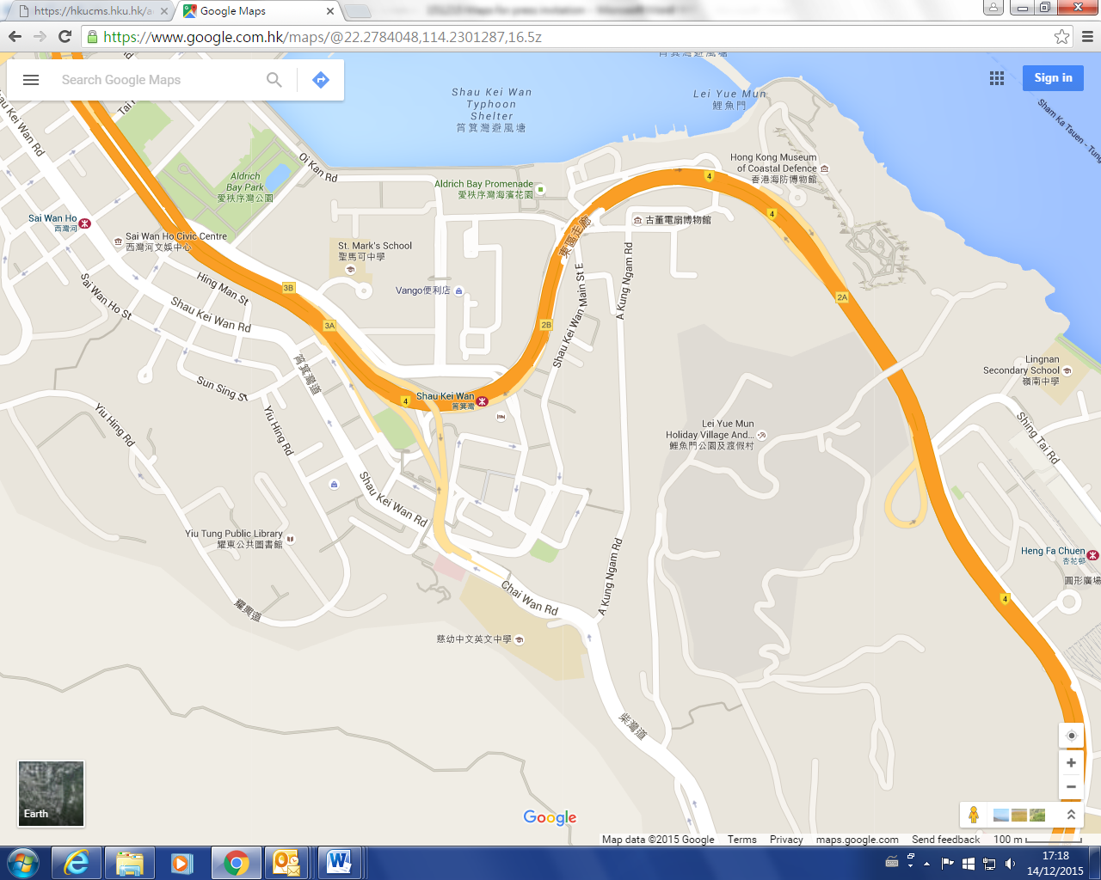

**Media pick-up point 2**

**(For those who will drive to Lei Yue Mun Park and Holiday Village)**

**\*\*Please gather at the main entrance of the Park at 1:50pm**